**“soft landing” VS “hard landing”**

**Objective:**

In this report, noise in hard landing case is found, two things need to be solved, **1) locate the source of the noise 2) minimize the noise.**

1. **Run traditional "hard" landing**

It is first run the traditional fast loading and unloading case, the loading condition is presented in figure 28.

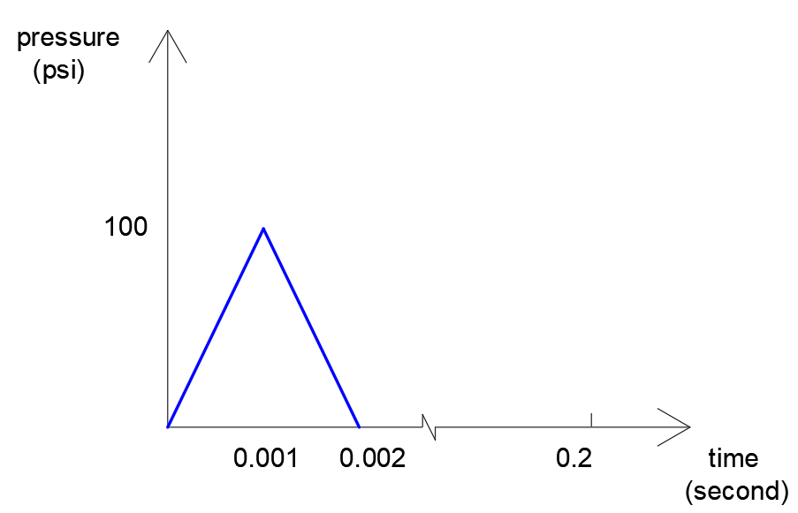

Fig.28 Traditional “hard” landing condition (copied from report 06032020 fig.24)

* 1. **stationary load**

In moving point case, the initial measuring point is chosen 200 inches away and then moved toward loading area, to compare the landing effect is equally compare the landing effect on measuring point in figure 29.

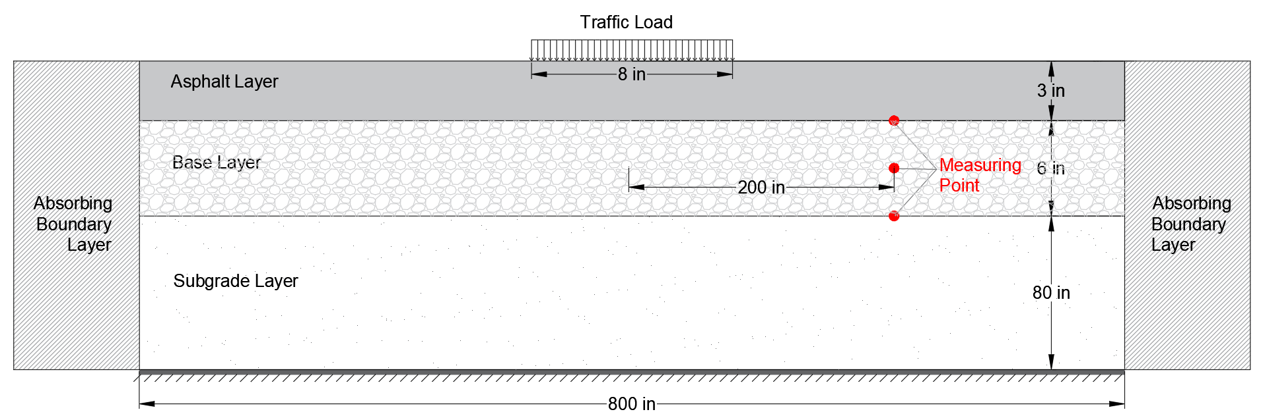

Fig. 29 measuring point

The time history of vertical stress at measuring points (200 inches away from measuring point, top/middle/bottom base) are presented in figures 30 a, b and c, respectively. The plots show that oscillation increases with depth, base bottom has more oscillation than top/middle base.

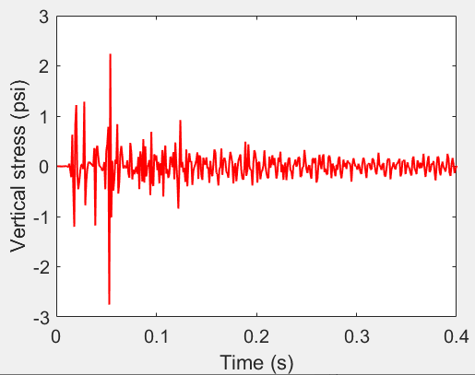

(a) top

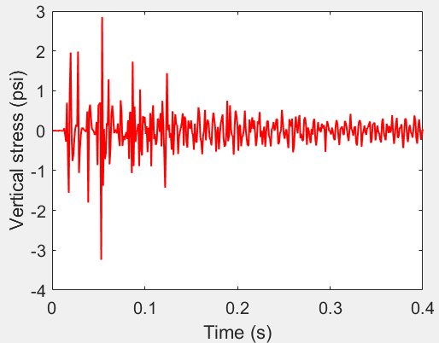

(b) middle

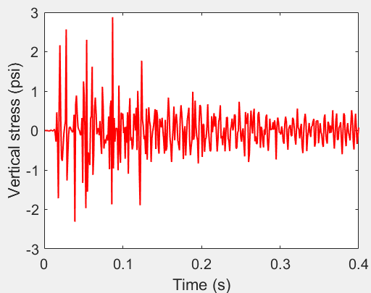

(c) bottom

Fig.30 Vertical stress at base layer

* 1. **moving point (comparison with moving load)**

The moving load and moving point under loading condition in figure 28 are compared and the results are presented in figure 31. These results were copied from report 06032020 and added the secondary axis (time). And can be seen that though both results **match up well** with each other, **noticeable noise is seen** in all three figures a-c.

|  |
| --- |
|  |
| (a) top |
|  |
|  |
| (b) middle |
|  |
|  |
| (c) bottom |

Fig.31 Moving point VS moving load (copied from report 06032020 fig.25)

1. **Run optimized “soft” landing**

To minimize the noise existed in fig. 31, a “soft landing” method is designed to lessen the “landing effect” caused by suddenly applied load at the beginning (**this landing part does not exist in reality**). The “soft landing” is presented in figure 32 a, where a 0.101 second ( 101 times slower than fast loading) is given to apply load slowly to the system then by using a combination with figure a and b presented in figure c, the load starts moving forward.

Thus, two steps are used here.

**Step1:** run case 1 with soft landing load (figure 32 a) and run case 2 with hard landing load (figure 32 b).

**Step2:** simulate moving load (figure 32 c). **Shift initial time point of case 2 (hard landing) to 0.102** **second and sum up with case 1 (soft landing) once**, then follow the same previous hard landing moving load procedure.

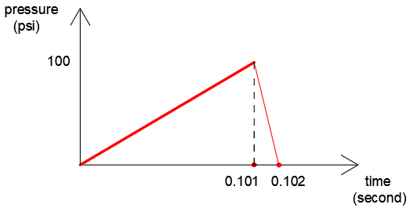

1. case 1, soft landing

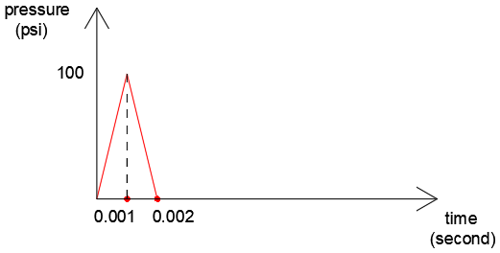

1. case 2, hard landing (traditional)

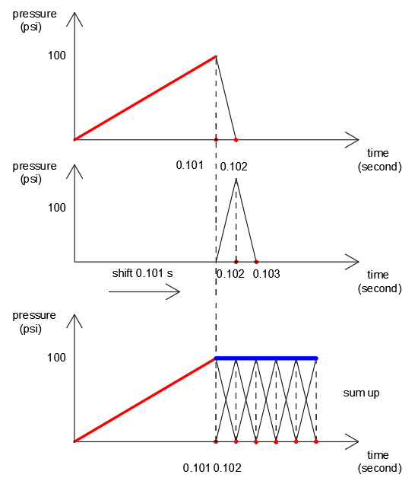

1. simulate moving load (after soft landing)

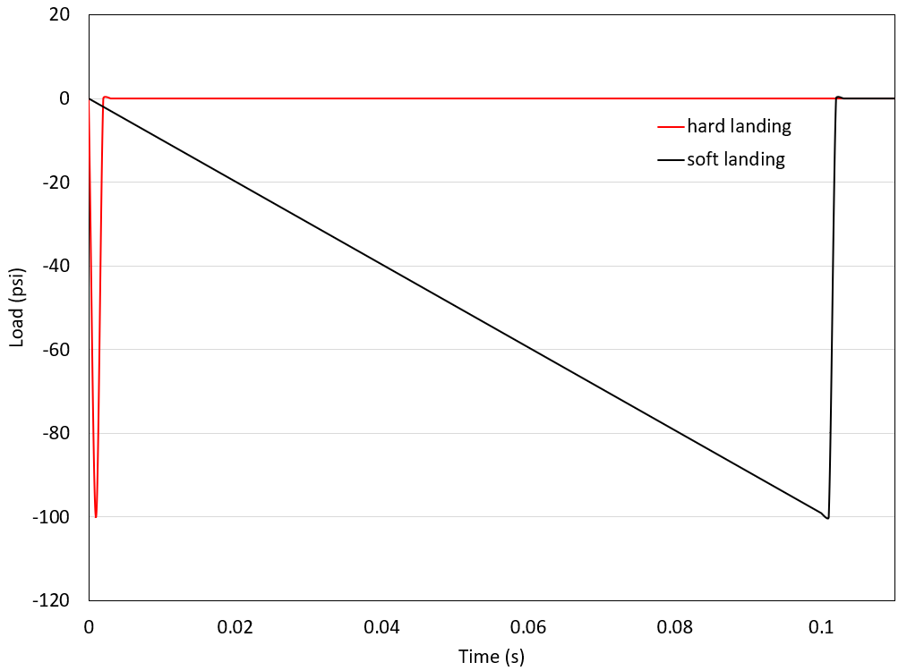

1. field data of hard/soft loading condition (in PEFIT, pressure unit is negative value)

Fig.32 loading condition illustration

* 1. **Stationary load**

The time history of vertical stress at measuring points (200 inches away from loading area, top/middle/bottom base, refer to figure 29) are presented in figures 33 a, b and c, respectively. The oscillation in plot after 0.1 second is not the same as it in figure 30, and a detailed comparison is discussed in part 3 of this report.

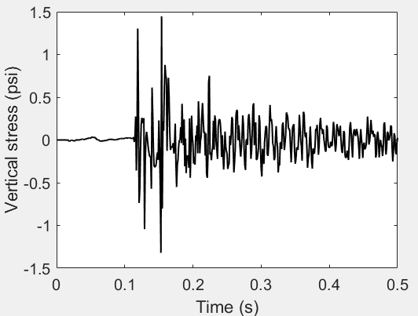

(a) top

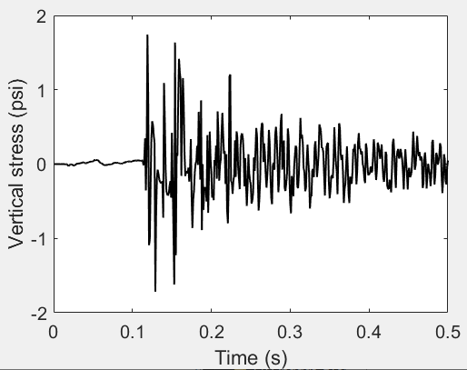

(b) middle

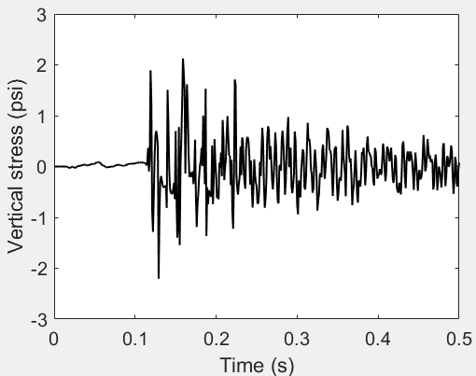

(c) bottom

Fig.33 Vertical stress at base layer

* 1. **moving point VS moving load (soft landing)**

The moving load and moving point under soft loading condition (figure 32 c) are compared and the results are presented in figure 34. As can be seen that results from moving point and moving load systems **match up well** with each other, and noise is effectively controlled.

|  |
| --- |
|  |
| (a) |
|  |
|  |
| (b) |
|  |
|  |
| (c) |

Fig.34 Moving point VS moving load (soft landing)

1. **Difference between “hard” landing and “soft” landing**

Figure 35 presents the results of soft landing and hard landing in moving point system. The results show that using soft landing, **noise is effectively minimized**, especially for measuring point at base bottom, in addition, peak point at the bottom measuring point also changes using soft landing.

**Note**: in figure 35, for both soft/hard landing cases, secondary axis time coordinate “0” denotes the beginning of unloading process, which for soft landing “0” corresponding to 0.101 second (figure 32 a); similarly for hard landing “0” corresponding to 0.001 second (figure 32 b).

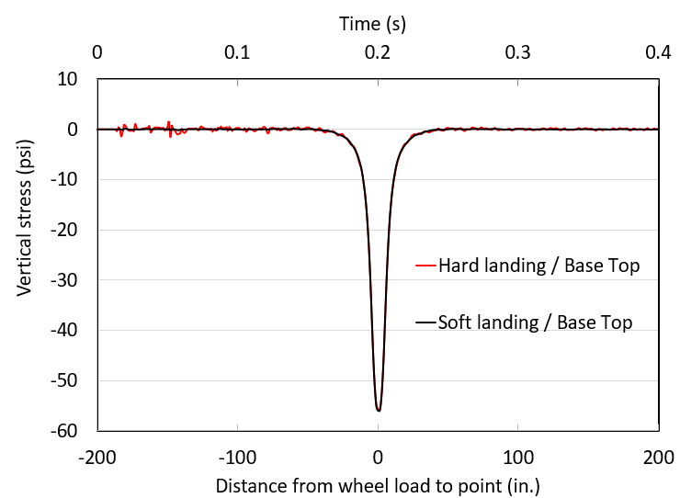

(a)

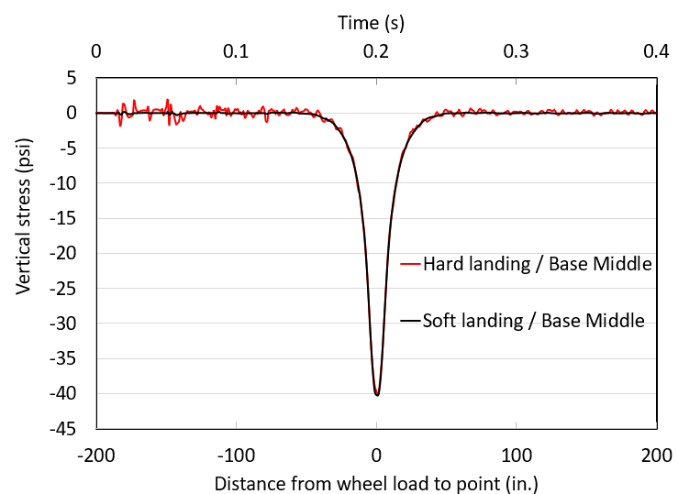

(b)

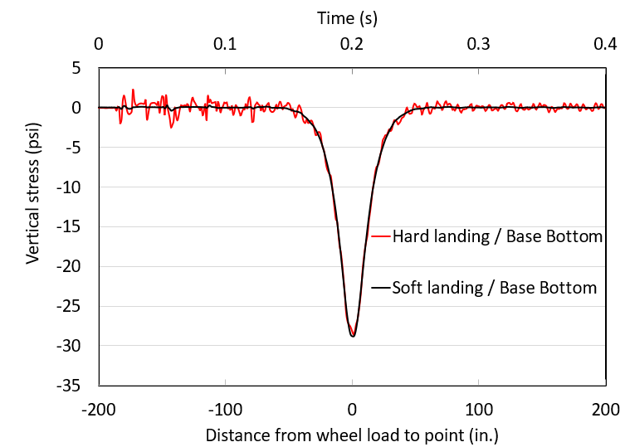

(c)

Fig.35 hard landing VS soft landing (moving point)

Figure 36 presents the time history outputs of hard landing (directly copied from figure 30) and soft landing (directly copied from figure 33) at measuring points (figure 29). In figures 36 a c and e, for soft landing case, slow loading (0.1 s) and fast unloading (0.001 s) condition are all included, since soft landing have 0.1 second for load applied on system, thus at first 0.1 second results of soft landing show values around zero. To better understand the oscillation between soft/hard landing conditions, in figures 36 b, d and f the first 0.101 second of soft landing results are cut and only the rest 0.4 second (unloading part) are compared with hard landing result. Both results present oscillation, but the oscillation that caused by unloading process is needed, it is a simulation of tire leaving the measuring point. Results of soft-landing cases present less oscillation especially at the beginning when load applied to the system. So again, the plots show the advantage of soft landing, and reflect that the noise of hard landing case basically comes from loading condition.

**[**Lucio has a comment here: “The question would be, how much oscillation is expected in reality? (you can add this question, you don’t have to know all the answers now). However, you cannot conclude too.”**]**

**[** Response from Zhe: Direct answer to the question, I don’t know. Because even the unloading process can also cause numerical noise, but this noise can be neutralized by adding loading process, also in moving load case, each time only two grids are loaded/unloaded, here the oscillation comes from whole loading area ( 8 inches) which should be proportionally decreased in the moving load case.**]**

|  |  |
| --- | --- |
|  |  |
| (a) top | (b) top |
|  |  |
|  |  |
| (c) middle | (d) middle |
|  |  |
|  |  |
| (e) bottom | (f) bottom |

Fig.36 hard landing VS soft landing

Moreover, to further ascertain the source of noise quantitatively, calculations are made. From figure 35 the noise at bottom is most noticeable, thus the bottom point is used to calculate the noise. Two subtractions are made:

**Difference 01**: In figure 35 c, the matrix (curve) of hard landing (matrix) subtracted from the curve (matrix) of soft landing. (both matrices start from moment of unloading process, 1.001 for soft landing case, 0.001 for hard landing case)

**Difference 02**: In figure 36 f, the matrix (curve) of hard landing (matrix) subtracted from the curve (matrix) of soft landing. (both matrices start from moment of unloading process, 1.001 for soft landing case, 0.001 for hard landing case).

Note: for detailed of subtraction process, please refer to the appendix.

Figure 37 a present the difference 01, which is the noise from hard landing, or in other words, the difference 01 is the noise seen in hard landing case (figure 35 c). Figure 37 b presents the difference 02, which is the time history output at measuring point (figure 29, bottom base). The difference of history output of hard/soft landing at this particular point is hypothesized as the source of the noise in figure 35 c hard landing case, to confirm such hypothesis, in figure 37 c, plot of difference 01/02 are compared and they completely match up.

Therefore, the noise is proved coming from the hard landing.

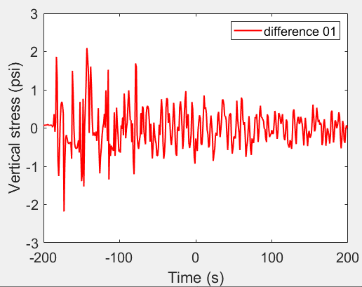

(a)

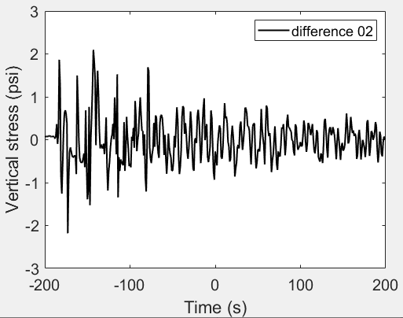

(b)

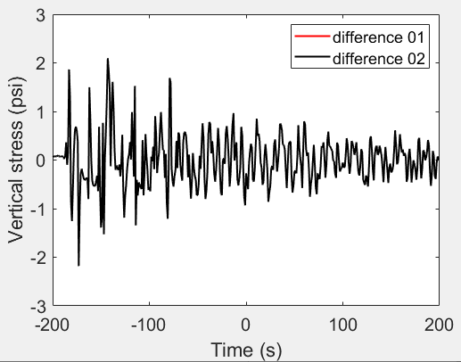

(c)

Fig.37 Difference between soft landing and hard landing

1. **Conclusion:**
2. Moving point case is checked with moving load case, both results match up well, which shows PEFIT works well in pure elastic case.
3. Noise in hard landing case comes from the loading condition at the beginning when whole pressure applied at the system.
4. Soft landing is an effective method to minimize the noise due to hard landing and moving point/ moving load case match up well.

**Appendix**

1. Checking the difference 02

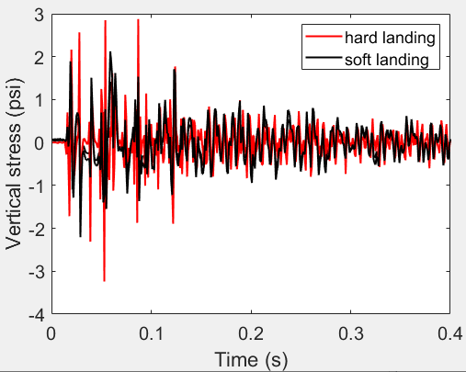 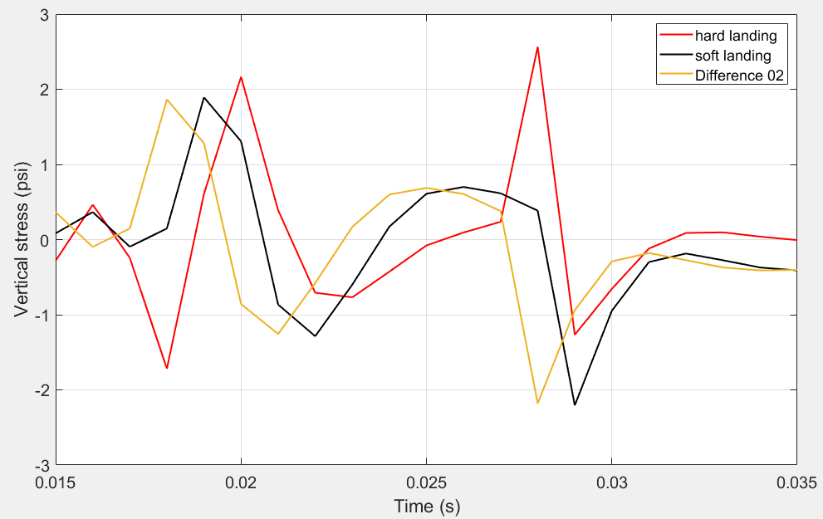

(a) Copied from fig.36 f (b) magnification plot of green box in (a)

Soft landing

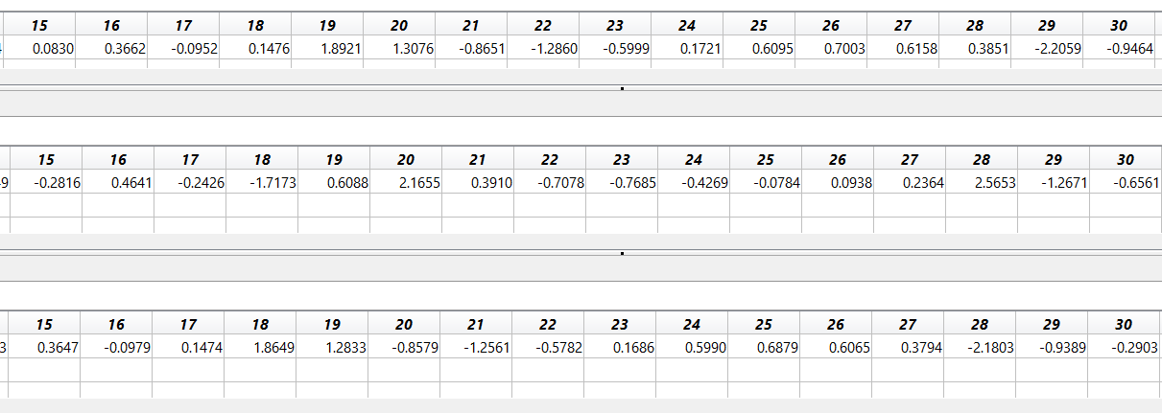

Difference 02

Hard landing

(c) Matrices according to boxes in figure b



(d) directly copied from fig37 b

Note: matrix of hard landing subtracted from matrix of soft landing

Fig. 38 matrices subtraction check for difference 02 in the report